The Matrix Map Tool: Programmatic Criteria for Your Organization

What specific criteria would support leadership in determining whether to invest in, reduce, or eliminate a program and/or organizational activity?
Criteria for Determining Organizational Effort? | Community Benefit Indicators? | Strategic Alignment Benchmarks? | Approach / Theory of Change Frameworks? | Values / Culture Integrity?
What will it take to establish these? | What will it take to establish these? | What will it take to establish these? | What will it take to establish these? | What will it take to establish these?

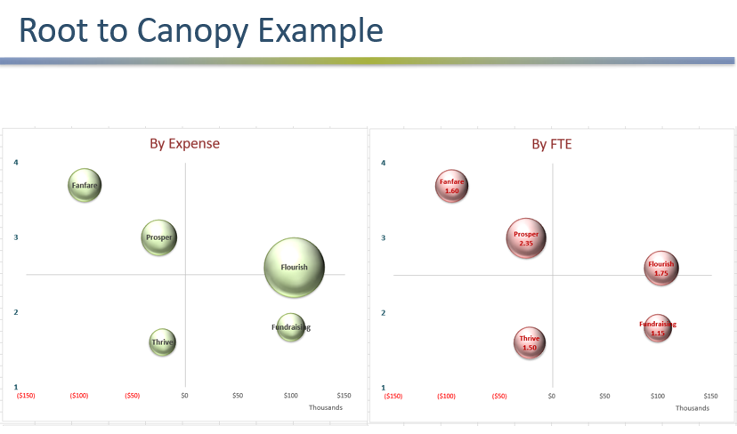

What questions come up for you when you look at these charts (individually or in comparison to one another)

